Table of Contents
1. Introduction 2
2. Objectives 2
3. Test Plan 2
3.1 Scope 2
3.2 Test Environment 3
3.3 Test Strategy 3
3.4 Entry and Exit Criteria 3
4. Test Scenarios 3
5. Test Cases (Sample) 3
6. Automation Framework Design (Page Object Model) 4
7. Automation Code 4
8. Handling Dynamic Elements 4
9. Data-Driven Testing 5
10. Performance Testing Scenarios (Documented) 5
11. Bug Report (Sample) 5
12. Test Execution Steps 6
13. Result 6
14. Conclusion 6
15. Screenshot 6
15.1 Login Page Screenshot 6
15.2 Add to Cart Screenshot 7
15.3 Cart Page Screenshot 7
15.4 Checkout & 7 Logout Page Screenshot 7
15.5 Error Message 8

Fully Automated E-commerce Website Testing
Website: https://www.saucedemo.com/
Tool Stack: Selenium WebDriver, Python, PyTest, Page Object Model (POM)

1. Introduction
SauceDemo is a demo e-commerce web application provided by Sauce Labs, widely used for practicing automation testing. This project demonstrates end-to-end automation testing of core e-commerce functionalities such as login, product selection, cart operations, and checkout using Selenium WebDriver with Python. The automation framework follows industry best practices including Page Object Model (POM) and PyTest.

2. Objectives
- To understand real-world e-commerce automation testing
- To design a complete automation test plan
- To identify and implement test scenarios and test cases
- To automate test cases using PyTest and Page Object Model
- To handle dynamic web elements and waits
- To perform user interactions such as clicks and form submissions
- To document performance testing scenarios
- To identify and report bugs or application limitations

3. Test Plan

3.1 Scope
In Scope:
- Login functionality validation
- Product listing page validation
- Add product to cart
- Cart page validation
- Checkout process (demo flow)
- Logout functionality
Out of Scope:
- Payment gateway validation (demo limitation)
- Backend and database testing
- Admin panel testing

3.2 Test Environment
- Operating System: Windows 10
- Browser: Google Chrome (latest version)
- Programming Language: Python 3.x
- Test Framework: PyTest
- Automation Tool: Selenium WebDriver

3.3 Test Strategy
- Functional automation testing
- Page Object Model for better maintainability
- Data-driven testing using CSV files
- Explicit waits for handling dynamic elements

3.4 Entry and Exit Criteria
Entry Criteria:
- Application is accessible
- Test data is available
- Test environment is ready
Exit Criteria:
- All planned test cases executed
- Critical defects reported
- Test results documented

4. Test Scenarios
Scenario ID | Description
TS01 | Verify login with valid credentials
TS02 | Verify login with invalid credentials
TS03 | Verify product listing page
TS04 | Verify add to cart functionality
TS05 | Verify checkout process
TS06 | Verify logout functionality

5. Test Cases (Sample)
Test Case Name: Add Product to Cart
- Test Case ID: TC_04
- Precondition: User is logged into SauceDemo
- Test Steps:
  - Select a product from the product list
  - Click on “Add to Cart”
  - Navigate to cart page
- Expected Result:
Selected product should be added to the cart successfully

6. Automation Framework Design (Page Object Model)
saucedemo/
│
├── pages/
│ ├── login_page.py
│ ├── products_page.py
│ ├── cart_page.py
│ └── checkout_page.py
│
├── tests/
│ ├── test_login.py
│ └── test_e2e_flow.py
│
├── utils/
│ ├── driver_factory.py
│ ├── wait_utils.py
│ └── bug_reporter.py
│
├── data/
│ └── login_data.csv
│
├── reports/
│ ├── report.html
│ └── bug_report.csv
│
├── conftest.py
└── pytest.ini

7. Automation Code
Login Page (login_page.py)
from selenium.webdriver.common.by import By
from pages.base_page import BasePage
class LoginPage(BasePage):
USERNAME = (By.ID, "user-name")
PASSWORD = (By.ID, "password")
LOGIN_BTN = (By.ID, "login-button")
def login(self, username, password):
self.driver.find_element(*self.USERNAME).send_keys(username)
self.driver.find_element(*self.PASSWORD).send_keys(password)
self.driver.find_element(*self.LOGIN_BTN).click()

8. Handling Dynamic Elements
Dynamic web elements are handled using explicit waits.
Techniques Used:
- WebDriverWait
- Expected Conditions
- Visibility and presence checks
Example:
self.wait.until(EC.visibility_of_element_located(locator))

9. Data-Driven Testing
Test Data (login_data.csv)
username,password
standard_user,secret_sauce
locked_out_user,secret_sauce
invalid_user,wrong_pass
CSV Reader (csv_reader.py)
import csv
def read_csv(path):
with open(path) as f:
return list(csv.DictReader(f))
Test Script (test_login_csv.py)
import pytest
from pages.login_page import LoginPage
from utils.csv_reader import read_csv
data = read_csv('testdata/login_data.csv')
@pytest.mark.parametrize('row', data)
def test_login_csv(driver, row):
login = LoginPage(driver)
login.login(row['username'], row['password'])
assert "Products" in driver.page_source

10. Performance Testing Scenarios (Documented)
Scenario ID | Description
PT01 | Login page load time
PT02 | Product page response time
PT03 | Add-to-cart response time
PT04 | Checkout page load time
Note: Performance testing is documented conceptually as Selenium is not designed for load testing.

11. Bug Report (Sample)
Bug ID: BUG_01
- Title: Error message not clear for locked-out user
- Severity: Medium
- Steps: Login using locked_out_user credentials
- Expected Result: Clear user-friendly error message
- Actual Result: Generic error message displayed

12. Test Execution Steps
- Install Python
- Install required dependencies
- pip install -r requirements.txt
- Download compatible ChromeDriver
- Run tests
- python -m pytest -v

13. Result
All major test cases were executed successfully. Login, product selection, cart operations, and checkout flow worked as expected. Minor usability issues were observed and documented during execution.

14. Conclusion
This project successfully demonstrates real-world automation testing of the SauceDemo e-commerce website using Selenium WebDriver with Python. The automation framework follows best practices such as Page Object Model, data-driven testing, and PyTest execution. The framework is scalable, maintainable, and suitable for academic submissions, internship evaluations, and automation testing practice.

15. Screenshot

15.1 Login Page Screenshot
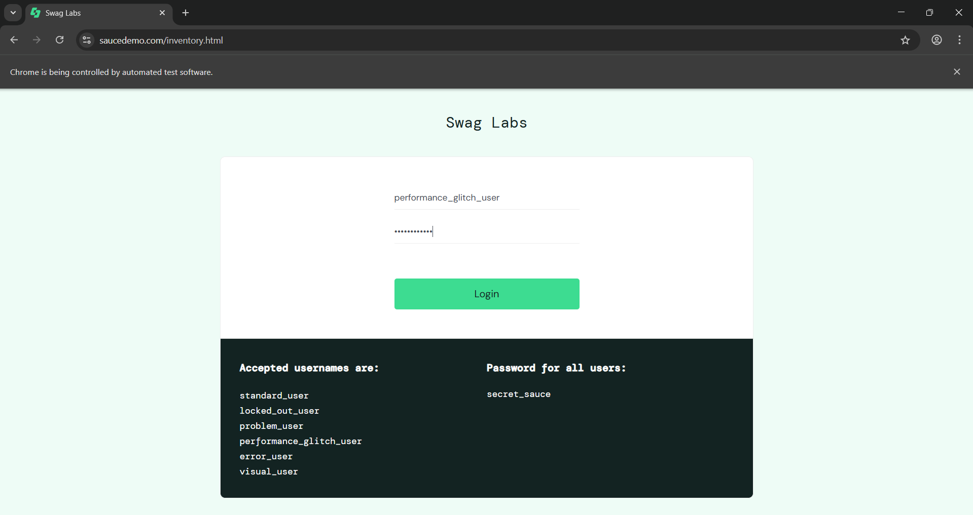
Figure 15. 1 SauceDemo Login Page

15.2 Add to Cart Screenshot
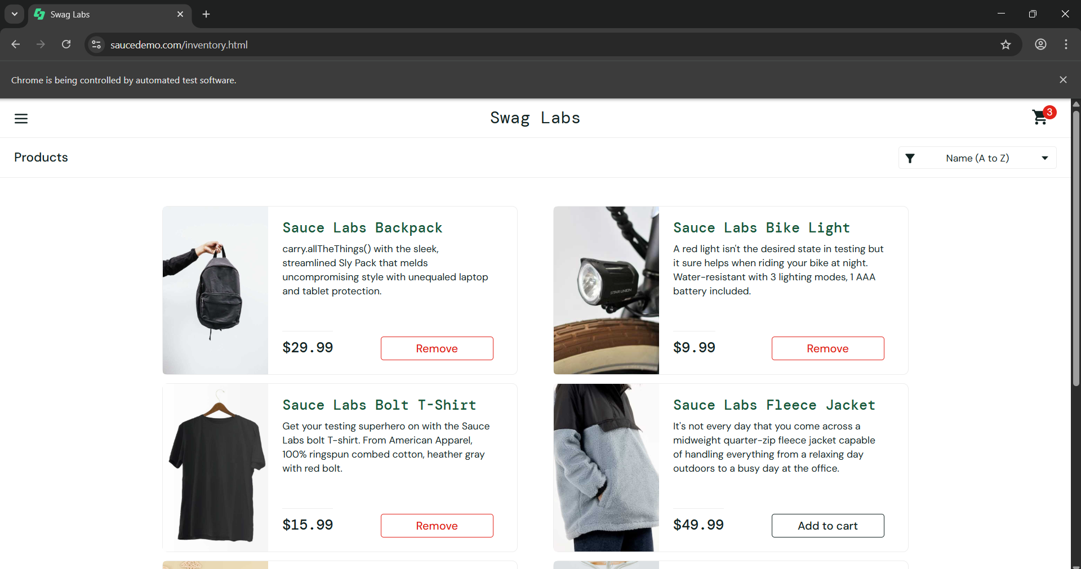
Figure 15. 2 Add to cart

15.3 Cart Page Screenshot
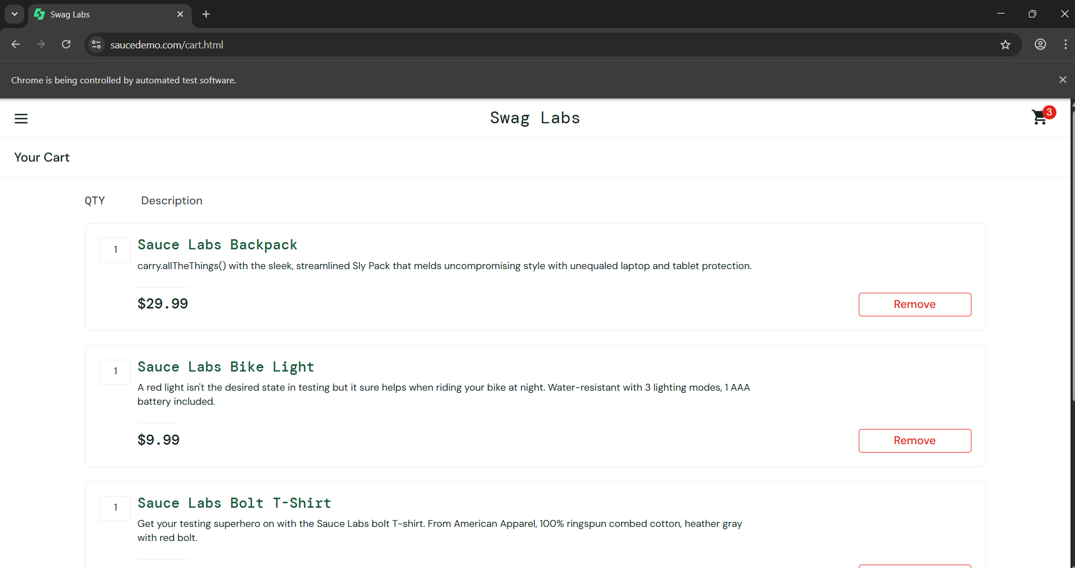
Figure 15. 3 Cart page

15.4 Checkout & 7 Logout Page Screenshot
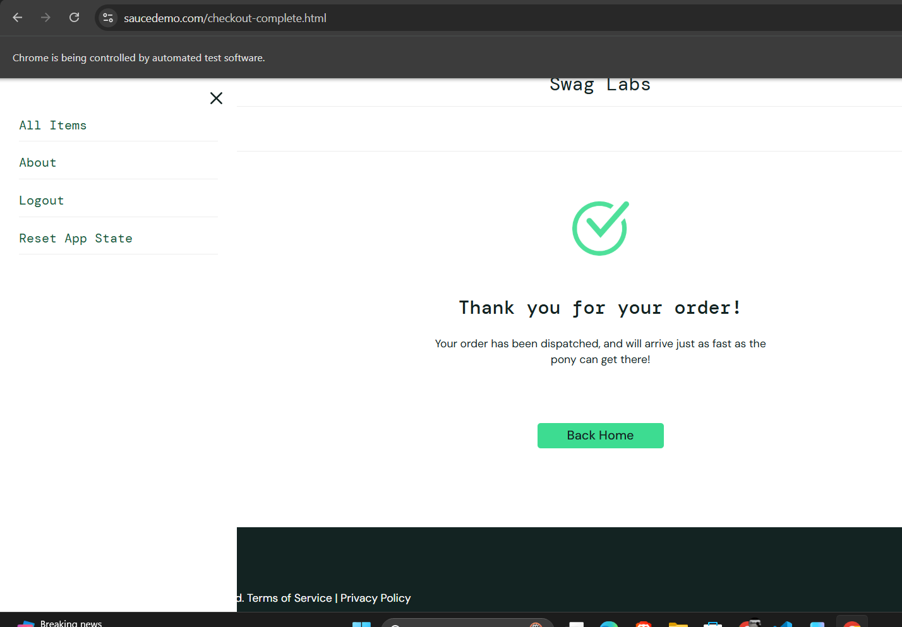
Figure 15. 4 Checkout & Logout page

